Reporting Platform

Background:
A nonprofit organization is struggling to track its transactions, making it difficult to clearly see how much money is coming in, how much is going out, and what funds remain available; without this visibility, the organization cannot confidently decide whether it should cut operational costs or reach out for additional funding to sustain its programs. My role was to restructure their raw financial data into a clean staging layer and a transformed layer for their analysis.

Data Pipeline - End to End Solution Component:
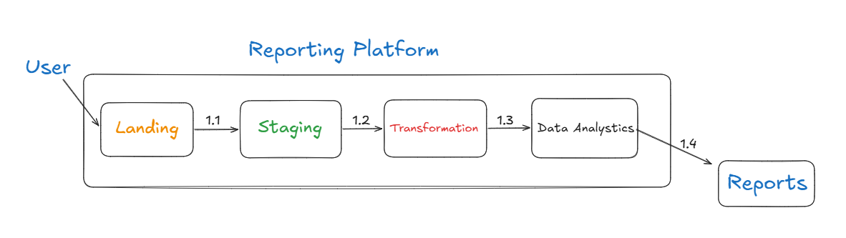
Data Pipeline Stages
Stage 1: The user places the three source data files into the input folder (csv file with | delimiter).

Stage 2: Each file is loaded into its corresponding staging table through a one‑to‑one Python ingestion process. The file name contains the business date, which is added as a column in the staging table to indicate the ‘as‑on’ date of the data. If the load fails, the process triggers notify_logger to send the appropriate message to the support team.

Stage 3: The staging tables (e.g., customer, account, address) are integrated and transformed into a consolidated dataset in the transformation layer. This is required to load directly to the target table in a sequential manner.

Stage 4: The consolidated dataset is then loaded one‑to‑one into the target platform, which is structured using a normalized data model.

Stage 5: End users generate reports from the dataset stored in the data analytics platform using their preferred reporting tools. The tool selection is currently being finalized.

Target DB Structure:
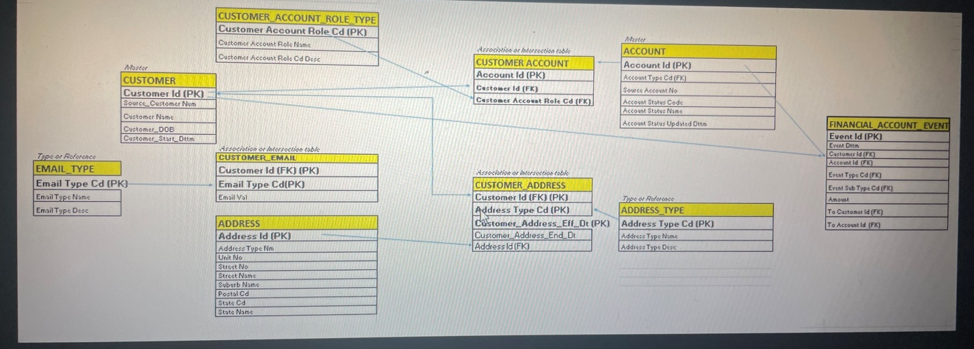

Source to Target Data Mapping: TO BE DONE.

Presentation Layer Reporting Views:
